H2
ANDERSON JUNIOR COLLEGE
HIGHER 2

CANDIDATE
NAME

PDG
INDEX NUMBER
PDG
I

BIOLOGY 9648/03

Applications Paper and Planning Question 18 September 2012
Paper 3

2 hours
Additional Materials: Answer Paper

READ THESE INSTRUCTIONS FIRST

Write your name and PD group on all the work you hand in.
Write in dark blue or black pen.
You may use a soft pencil for any diagrams, graph or rough working.
Do not use paper clips, highlighters, glue or correction fluid.

Answer all questions.

All working for numerical answers must be shown.
For Examiner’s Use
1
2
3
4
5
Total | 72
At the end of the examination, fasten all your work securely together.
The number of marks is given in brackets [ ] at the end of each question or part question.

Calculators may be used

This document consists of 15 printed pages and 1 blank page.
Answer all the questions.

1 |  | Human growth hormone (hGH) is essential for normal growth and development. Currently, recombinant hGH synthesised via genetic engineering is exclusively used to treat GH deficiency. Prior to the development of genetic engineering, hGH is obtained mainly from cadavers (dead body).
 | (a) | Explain the advantages of obtaining hGH gene from a cDNA library instead of a genomic DNA library.  …………………………………………………………………………………..……………………...  …………………………………………………………………………………..……………………...  …………………………………………………………………………………..……………………...  …………………………………………………………………………………………………………  ………………………………………………………………………………………………………… | [3]
 | (b) | The plasmids used for cloning hGH gene were obtained from E. Coli and modified to contain the following:  - Resistance genes for antibiotics kanamycin and ampicillin.  - Prokaryotic promoter sequence (P) upstream of the ampicillin gene  - Polylinker site which contains recognition sites of 7 different restriction enzymes, all producing sticky ends.  Fig. 1.1 shows the plasmid used for cloning:  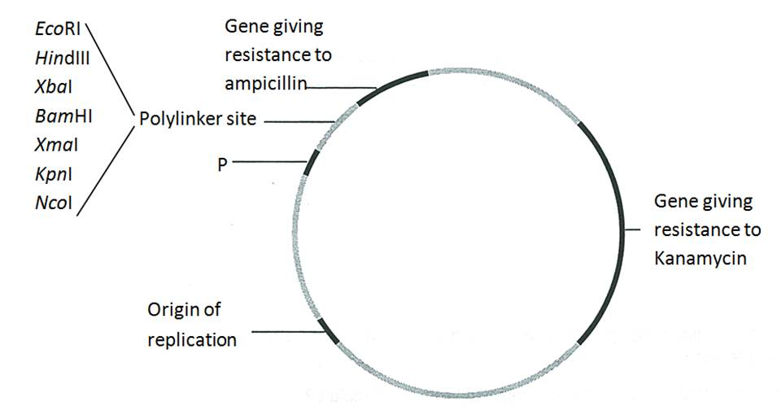  Fig. 1.1  The cDNA of hGH gene, with the restriction sites flanking the gene, is shown in Fig 1.2.  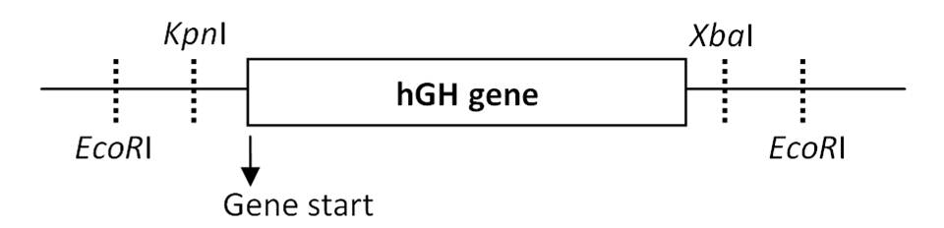  Fig. 1.2
 | (i) | In order to obtain a recombinant plasmid containing the hGH gene, the hGH cDNA and cloning plasmids are first digested with restriction enzymes prior to annealing them together.  State the restriction enzymes used in order to obtain optimum gene expression.  …………………………………………………………………………………..……………………... | [1]

 | (ii) | Explain your choice of restriction enzymes.  …………………………………………………………………………………..……………………...  …………………………………………………………………………………..……………………...  …………………………………………………………………………………..……………………... | [2]
The recombinant plasmids were transformed into E.Coli cells. Selection of recombinant bacterial clones was then carried out by culturing them on media containing antibiotics. The same colonies are plated in the same grid positions on the two plates shown below.

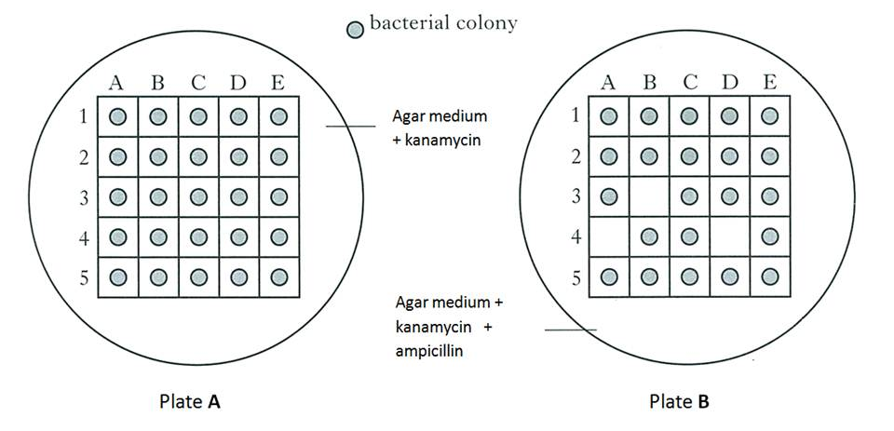
Fig. 1.3

 | (c) | State and explain which colonies contained the recombinant plasmids with hGH gene.  …………………………………………………………………………………………………………  …………………………………………………………………………………………………………  …………………………………………………………………………………………………………. | [2]

 | (d) | A pharmaceutical company tried to produce hGH using the same method described but they transformed another species of bacterial cells with the recombinant plasmids. Recombinant plasmids were successfully inserted into the bacterial cells but after several generations, the bacterial cells were unable to grow on the kanamycin medium.  Suggest a possible reason.  ………………………………………………………………………………………………………….  ………………………………………………………………………………………………………….  ………………………………………………………………………………………………………….  …………………………………………………………………………………………………………. | [2]
 | (e) | Explain the advantages of being able to transfer hGH genes into bacteria.  …………………………………………………………………………………………………………  …………………………………………………………………………………………………………  …………………………………………………………………………………………………………  …………………………………………………………………………………………………………. | [2]
 |  | [Total: 12]

2 |  | Cystic fibrosis (CF) is a genetic disorder caused by mutations in the gene that code for the CF transmembrane conductance regulator (CFTR) that contributes to regulation of ion flux at the membrane of epithelial cells.  A polymorphic DNA segment, KM-19 found within 1 Centimorgan of the CFTR gene has been identified. This segment exhibits restriction fragment length polymorphism (RFLP) that can be used as a marker for the genetic screening of CF.  Fig. 2.1 shows the positions of various restriction sites of a segment of KM-19 and a probe that can be used to detect the polymorphism. Allele 2 is linked to the mutant CFTR allele.  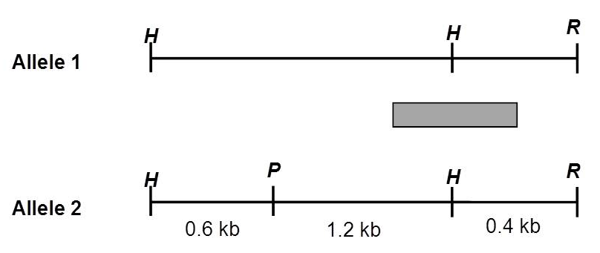  Diagram not drawn to scale  H, P and R represent restriction sites HindIII, PstI and EcoRI respectively.  Fig. 2.1
 | (a) | With reference to information in the question and Fig. 2.1, explain why KM-19 can be used as a genetic marker for the detection of the mutant CFTR allele.  …………………………………………………………………………………..……………………...  …………………………………………………………………………………..……………………...  …………………………………………………………………………………..……………………...  …………………………………………………………………………………..……………………...  …………………………………………………………………………………..……………………...  …………………………………………………………………………………..……………………... | [4]
 | (b) | The first step of genetic screening for CF involves performing polymerase chain reaction (PCR) on extracted DNA to amplify the KM-19 region.
 | (i) | Describe one advantage of PCR.  …………………………………………………………………………………..……………………...  …………………………………………………………………………………..……………………... | [1]
 | (ii) | Fig 2.2 shows the number of molecules of DNA produced over a number of PCR cycles.  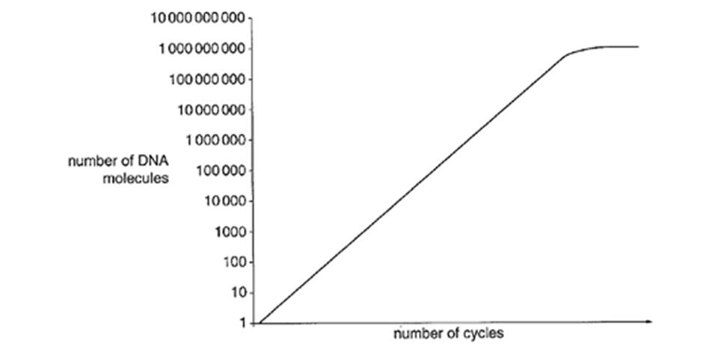  Fig. 2.2  Suggest two reasons why the graph levels off.  …………………………………………………………………………………..……………………...  …………………………………………………………………………………..……………………...  …………………………………………………………………………………..……………………...  …………………………………………………………………………………..……………………... | [2]

 | (c) | Fig. 2.3 shows the genetic screening results for CF in a family. The amplified DNA containing KM-19 was digested with restriction enzymes followed by gel electrophoresis and Southern blotting using the probe shown in Fig. 2.1.  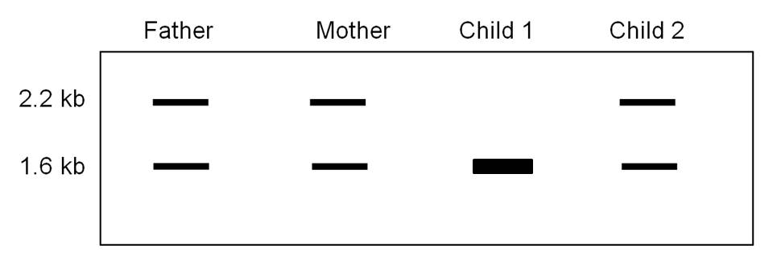  Fig. 2.3
 | (i) | Based on Fig 2.1 and the results shown in Fig. 2.3, explain if Child 1 is likely to get cystic fibrosis.  …………………………………………………………………………………..……………………...  …………………………………………………………………………………..……………………... | [1]
 | (ii) | If Child 2 shows symptoms of CF, suggest a reason based on inheritance for the banding pattern obtained in Child 2.  …………………………………………………………………………………..……………………...  …………………………………………………………………………………..……………………...  …………………………………………………………………………………..……………………...  …………………………………………………………………………………..……………………...  …………………………………………………………………………………..……………………... | [3]
 |  | BLANK PAGE
 | (d) | Recently, scientists discovered the presence of a population of bone-marrow derived stem cells that are distinct from hematopoietic stem cells. These multipotent stem cells have the ability to differentiate into lung epithelial cells and could possibly be used to replace the current methods of gene therapy for treatment of CF.  An experiment was carried out to compare the effects of 3 different treatments for CF.  CFTR-Knock Out (CFTR-KO) mice which did not express the CFTR gene were divided into 3 groups and given three different treatments.  - Treatment A: CFTR-KO mice were given a liposome-encapsulated DNA containing normal allele of CFTR by nasal aerosol.  - Treatment B: Bone marrow stem cells were transplanted from healthy donor mice expressing CFTR gene into CFTR-KO mice. The CFTR-KO mice in this group had their immune system suppressed to prevent them from rejecting the donor bone marrow stem cells.  - Treatment C: Lung epithelial cells were isolated from CFTR-KO mice and genetically modified. Cells which successfully express normal CFTR were introduced back into CFTR-KO mice.  Table 2.4 shows the percentage of lung epithelial cells with normal CFTR expression counted on 3, 7 and 10 days after the treatments.  Percentage of lung epithelial cells with normal CFTR expression  - : less than 20% + : 20 %- 39% ++ : 40 % - 60% +++ : more than 60%  Table 2.4
  Treatment | Mice | Percentage of lung epithelial cells with normal CFTR expression
  Treatment | Mice | Day 3 | Day 7 | Day 10
  A | 1 | +++ | ++ | -
  A | 2 | +++ | + | -
  A | 3 | +++ | ++ | -
  B | 1 | +++ | +++ | ++
  B | 2 | +++ | +++ | +++
  B | 3 | ++ | ++ | ++
  C | 1 | + | - | -
  C | 2 | - | - | -
  C | 3 | - | - | -

 | (i) | With reference to Table 2.4, explain why Treatment B is more effective than Treatment A.  …………………………………………………………………………………..……………………...  …………………………………………………………………………………..……………………...  …………………………………………………………………………………..……………………...  …………………………………………………………………………………..……………………...  …………………………………………………………………………………..……………………... | [3]
 | (ii) | From the experiment, discuss the implications of the following treatments for CF patients:
 |  | Treatment B.  …………………………………………………………………………………..……………………... | [1]
 |  | Treatment C.  …………………………………………………………………………………..……………………...  …………………………………………………………………………………..……………………... | [2]
 |  | [Total: 17]

3 |  | Tobacco (Nicotiana tabacum) plants can be genetically modified to express a gene coding for a viral coat protein (CP) from the tobacco mosaic virus (TMV). CP, which is found on the surface of the virus, turns on the plant immune system. The transgenic tobacco plants with this gene will become vaccinated and therefore be immune to TMV. This increases yield of tobacco plants.  Several types of plant tissue cultures can be used for insertion of foreign genes, such as protoplast culture, root culture and anther culture.
 | (a) | Explain why protoplast cells are ideal transformation targets.  …………………………………………………………………………………..……………………...  …………………………………………………………………………………..……………………...  …………………………………………………………………………………..……………………... | [2]
 | (b) | The CP gene sequence is isolated from TMV and inserted into a Ti plasmid that also contains an antibiotic gene for selection in plant cells. The Ti plasmid is then inserted into a soil bacterium called Agrobacterium tumefaciens (Agrobacter) and subsequently used to infect tobacco protoplast cells. The transformed plant cells are grown in culture to regenerate tobacco plants.  Equal numbers of transgenic and normal tobacco plants (control) are inoculated with both TMV and tomato mosaic virus (ToMV) and left for five days.  The mean percentage of surviving leaves was calculated in each type of tobacco plants and the results are shown in Fig. 3.1  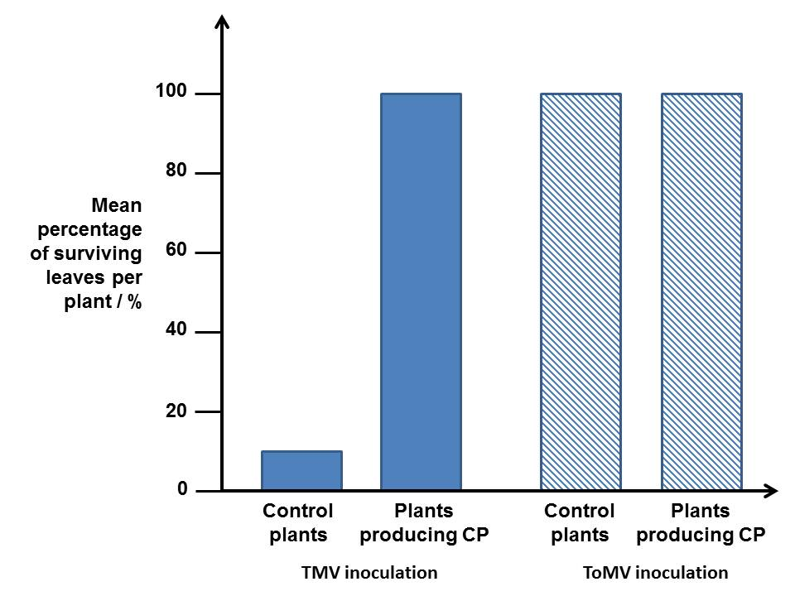  Fig. 3.1  With reference to Fig. 3.1,
 | (i) | explain the effect of CP on the yield of tobacco plants inoculated with TMV.  …………………………………………………………………………………..……………………...  …………………………………………………………………………………..……………………...  …………………………………………………………………………………..……………………... | [2]
 | (ii) | explain if CP vaccinates tobacco plants against ToMV.  …………………………………………………………………………………..……………………...  …………………………………………………………………………………..……………………...  …………………………………………………………………………………..……………………...  …………………………………………………………………………………..……………………... | [2]
 | (c) | An alternative method of vaccinating tobacco plants against TMV is to transform tobacco plant cells with a gene coding for RNA (siRNA) which has complementary sequence to the viral mRNA of a TMV protein critical for viral replication. The translation of viral mRNA into viral proteins is reduced.  Explain how expression of siRNA can lead to the reduction of viral mRNA translation.  …………………………………………………………………………………..……………………...  …………………………………………………………………………………..……………………...  …………………………………………………………………………………..……………………... | [2]
 | (d) | Genetic engineering which involves introducing genes from other species into crop plants has also led to production of crops such as Bt corn and golden rice.  Between the years 1900 and 2000, crop yields across the world increased by almost 300%.  Discuss why such genetic engineering has contributed little to this rise in yield and explain your answer.  …………………………………………………………………………………..……………………...  …………………………………………………………………………………..……………………...  …………………………………………………………………………………..……………………...  …………………………………………………………………………………..……………………... | [3]
 |  | [Total: 11]

4 |  | Planning question
P1 is a temperate phage that infects Escherichia coli. It is an unusual phage in that during the lysogenic stage, it’s DNA remain transcriptional silent and exists as an independent circular DNA plasmid-like element rather than integrates into the host genome like other temperate bacteria phage. In its lytic phase, P1 can produce transducing phages which carry part of the bacterial genome. Induction of P1 from the lysogenic cycle to the lytic cycle is known to occur over a temperature range of 32ºC to 52ºC.

You are required to plan, but not carry out, an investigation to determine the optimum temperature at which induction of P1 phage from the lysogenic cycle into the lytic cycle occurs.

Induction from the lysogenic to lytic cycle can be determined by observing the gene expression of β-galactosidase. β-galactosidase is an enzyme made up of two peptides, lac Z-α and lac Z-Ω, neither of which is active by itself but when both are present together, they spontaneously reassemble into a functional enzyme.

In mutant E.coli with a deletion in the lac operon, β-galactosidase lacking the lac Z-α is produced. The mutation can be repaired by transduction with P1 transducing phages which have been previously been reproduced in E.coli that do not contain the deletion in lac operon. These transducing phages contain DNA encoding lac Z-α.

Upon transduction of the mutant, lac operon deficient E.coli with transducing phages containing DNA encoding lac Z-α, the amount of β -galactosidase produced in the bacterial cell can be measured using a colorless chemical known as X-gal. Hydrolysis of X-gal by β -galactosidase will result in the formation of a blue product. The color intensity of the product can then be assayed using a colorimeter which measures the absorbance of different wavelengths of light in a solution in absorbance units (A.U). A solution of higher color intensity will absorb more light energy at a specific wavelength.

Your plan should:

- have an explanation of theory to support your practical procedure
- have a clear and helpful structure such that the method you use is able to be repeated by anyone reading it
- include layout of results tables and graphs with clear headings and labels
- include full details and explanations of the procedures that you would adopt to ensure that the results obtained were as quantitative, precise and reliable as possible
- include relevant risks and precautions taken.
[Total: 12]

Your planning must be based on the assumption that you have been provided with the following equipment and materials, which you must use:

- a glucose-deficient liquid culture of mutant E.coli previously infected with P1 transducing phages carrying DNA encoding for lac Z-α. The transduced mutant E.coli culture is kept at 30ºC. P1 phages are known to exist as lysogens in mutant E.coli cells at 30ºC.
- lactose solution
- thermostatically regulated waterbath
- colorimeter with accompanying cuvettes
- liquid X-gal
- stopwatch
- sterile test tubes
- a variety of syringes for measuring volumes
…………………………………………………………………………………..……………………...

…………………………………………………………………………………..……………………...

…………………………………………………………………………………..……………………...

…………………………………………………………………………………..……………………...

…………………………………………………………………………………..……………………...

…………………………………………………………………………………..……………………...

…………………………………………………………………………………..……………………...

…………………………………………………………………………………..……………………...

…………………………………………………………………………………..……………………...

…………………………………………………………………………………..……………………...

…………………………………………………………………………………..……………………...

…………………………………………………………………………………..……………………...

………………………………………………………………………………………………………….

…………………………………………………………………………………..……………………...

…………………………………………………………………………………..……………………...

…………………………………………………………………………………..……………………...

…………………………………………………………………………………..……………………...

………………………………………………………………………………………………………….

…………………………………………………………………………………..……………………...

…………………………………………………………………………………..……………………...

…………………………………………………………………………………..……………………...

…………………………………………………………………………………..……………………...

………………………………………………………………………………………………………….

…………………………………………………………………………………..……………………...

…………………………………………………………………………………..……………………...

…………………………………………………………………………………..……………………...

…………………………………………………………………………………..……………………...

………………………………………………………………………………………………………….

………………………………………………………………………………………………………….

…………………………………………………………………………………..……………………...

…………………………………………………………………………………..……………………...

…………………………………………………………………………………..……………………...

…………………………………………………………………………………..……………………...

…………………………………………………………………………………..……………………...

…………………………………………………………………………………..……………………...

…………………………………………………………………………………..……………………...

…………………………………………………………………………………..……………………...

…………………………………………………………………………………..……………………...

…………………………………………………………………………………..……………………...

…………………………………………………………………………………..……………………...

…………………………………………………………………………………..……………………...

…………………………………………………………………………………..……………………...

…………………………………………………………………………………..……………………...

…………………………………………………………………………………..……………………...

…………………………………………………………………………………..……………………...

…………………………………………………………………………………..……………………...

…………………………………………………………………………………..……………………...

………………………………………………………………………………………………………….

………………………………………………………………………………………………………….
…………………………………………………………………………………..……………………...

…………………………………………………………………………………..……………………...

…………………………………………………………………………………..……………………...

…………………………………………………………………………………..……………………...

…………………………………………………………………………………..……………………...

…………………………………………………………………………………..……………………...

…………………………………………………………………………………..……………………...

…………………………………………………………………………………..……………………...

…………………………………………………………………………………..……………………...

…………………………………………………………………………………..……………………...

…………………………………………………………………………………..……………………...

…………………………………………………………………………………..……………………...

…………………………………………………………………………………..……………………...

…………………………………………………………………………………..……………………...

…………………………………………………………………………………..……………………...

…………………………………………………………………………………..……………………...

…………………………………………………………………………………..……………………...

…………………………………………………………………………………..……………………...

…………………………………………………………………………………..……………………...

…………………………………………………………………………………..……………………...

…………………………………………………………………………………..……………………...

…………………………………………………………………………………..……………………...

…………………………………………………………………………………..……………………...

…………………………………………………………………………………..……………………...

…………………………………………………………………………………..……………………...

…………………………………………………………………………………..……………………...

…………………………………………………………………………………..……………………...

…………………………………………………………………………………..……………………...

…………………………………………………………………………………..……………………...

Free-response question

Write your answers to this question on the separate answer paper provided.

Your answer:

- should be illustrated by large, clearly labelled diagrams, where appropriate;
- must be in continuous prose, where appropriate;
- must be set out in sections (a), (b) etc., as indicated in the question.

5 | (a) | Outline Nucleic Acid Hybridisation and explain how it can be used in the detection of DNA sequences. | [10]
 | (b) | Discuss the ethical implications of genetically modifying plants. | [5]
 | (c) | Discuss the goals of the human genome project. | [5]
 |  | [Total: 20]

